Infosys Springboard Virtual Internship7.0
COMPLETION REPORT
Team Details: | Team D (Mentor: Selciya)
Batch Number: | Batch 2
Internship Duration: | 8 Weeks
Team Members: | 1. Rajeswari Teppala  2. Eswar Reddy Anush  3. Sachin A S  4. Sindhukay Ernapati  5. Vabyasha Mohapatra  6. Vaishnavi Kumari  7. Vyshnavi Ganta
1. Project Title
AI-BASED INDUSTRIAL MAINTENANCE & PROCESS OPTIMIZATION (FactoryOps Platform)
2. Project Objective
The main goal of this project is to build an intelligent, predictive maintenance and real-time asset tracking platform named FactoryOps. The platform aims to reduce unscheduled industrial downtime, optimize machine lifespan, monitor plant health parameters (such as temperature, operational risk, and asset availability), and automate maintenance scheduling using machine learning model predictions.
3. Project Description in Detail
The FactoryOps platform utilizes modern full-stack web development paired with machine learning algorithms for real-time telemetry processing and risk forecasting.
- Approach: Built a modular dashboard supporting system administrator and operations lead roles. Continuous sensor telemetry streams temperature, operational health score, and failure probabilities for registered machinery.
- Technology Used: Python (scikit-learn, Pandas) for predictive ML pipelines, React/Node.js for dynamic UI rendering, REST APIs for telemetry synchronization, and SQL/NoSQL databases for work order and asset management records.
- Real-World Impact: Eliminates reactive maintenance cost spikes, reduces machine downtime across multi-plant environments (e.g., Plant A, Plant B, Plant C), and prioritizes active work orders based on predictive health risk analytics.
4. Timeline Overview
Week | Activities Planned | Activities Completed
Week 1 | Requirement analysis & system architecture design | Defined project scope, database models, and UI wireframes
Week 2 | Platform setup & authentication module design | Developed role-based authentication (admin, Operations Lead)
Week 3 | Telemetry data simulation & backend API build | Built APIs for asset registration, health indexing, and telemetry tracking
Week 4 | Predictive model development | Trained ML models to compute failure probability and risk scores
Week 5 | Dashboard & Fleet view development | Implemented real-time Fleet tables, Health vs Risk distribution charts
Week 6 | Maintenance & Work Order module build | Created work order tracking, cost tracking, and priority queues
Week 7 | System integration & testing | Integrated front-end components with ML backend APIs; system validation
Week 8 | Documentation & final presentation | Generated completion report, video demos, and final project deck
5a. Key Milestones
Milestone | Description | Date Achieved
Project Kickoff | Team setup, mentor alignment with Selciya, requirement finalization | Week 1
Prototype / First Draft | Authentication login screens and static asset listing views completed | Week 3
Mid-Term Review | Working predictive risk ranking and fleet registry demonstration | Week 5
Final Submission | Full platform functionality (Dashboard, Fleet, Predictions, Maintenance) | Week 7
Presentation | Final project presentation and evaluation report submission | Week 8

5b. Project Execution Details
1. Authentication & Access Control: Role-based secure portal for Operations Leads and Administrators (admin).
2. Real-time Asset Monitoring (Fleet): Built an operational registry tracking 52 registered assets across multiple plants, listing parameters like operational status (Running, Idle, Maintenance), machine temperature, health percentage, and failure risk percentage.
3. Predictive Maintenance Module: Integrated ML model output into a visual Priority Queue and 'Health against risk' distribution chart to prioritize at-risk machinery (e.g., Boiler Unit, Hydraulic Press, Cooling System).
4. Work Order Management: Created automated maintenance logging system keeping track of job types (Inspection, Preventive, Predictive, Corrective), technician assignments, total jobs (30), active tasks (6), completed tasks (24), and recorded maintenance costs (70,300 currency units).
5.Requirement Analysis: Identified requirements for machine monitoring, predictive maintenance, and process optimization. Example: Monitoring machine temperature and operating status.
6.System Architecture: Designed separate frontend, backend, database, and AI modules. Example: Streamlit dashboard connected to FastAPI APIs.
7.Data Collection: Collected and processed machine sensor and operational data. Example: Temperature, vibration, and machine status readings.
8.Backend Development: Developed APIs for managing machines, predictions, incidents, and maintenance. Example: FastAPI /predictions API.
9.Frontend Development: Created an interactive dashboard for monitoring industrial operations. Example: Displaying machine health and maintenance status.
10.Testing & Validation: Tested system modules, APIs, database operations, and dashboard functionality. Example: Checking whether prediction results appear correctly on the dashboard.
11.Final Deployment: Prepared the FactoryOps Platform for practical industrial monitoring and maintenance use. Example: Providing a centralized dashboard for plant operations

6. Snapshots / Screenshots
Snapshot 6.1: FactoryOps Authentication Interface
User login interface with role-based sign-in for platform security.
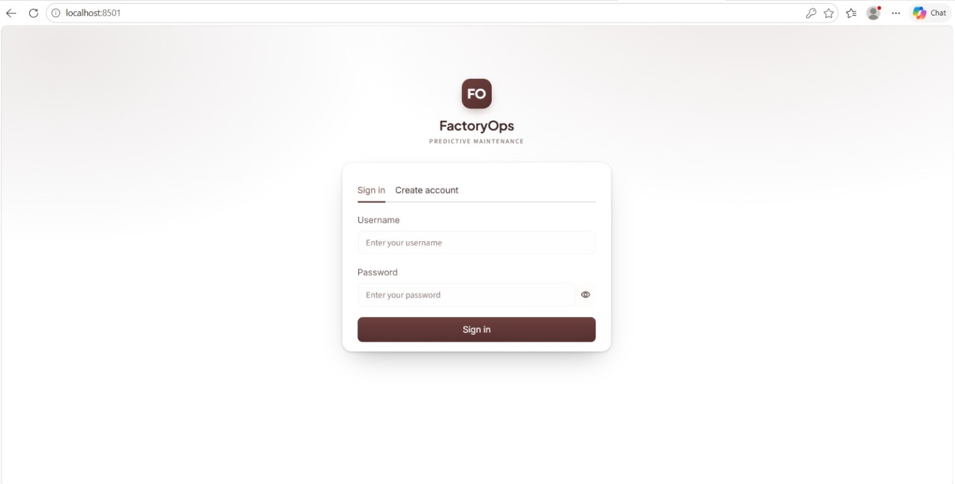
Snapshot 6.2: System Welcome & Asset Overview
Operations Lead landing dashboard displaying registered assets (52), open incidents (13), and system backend connection status.
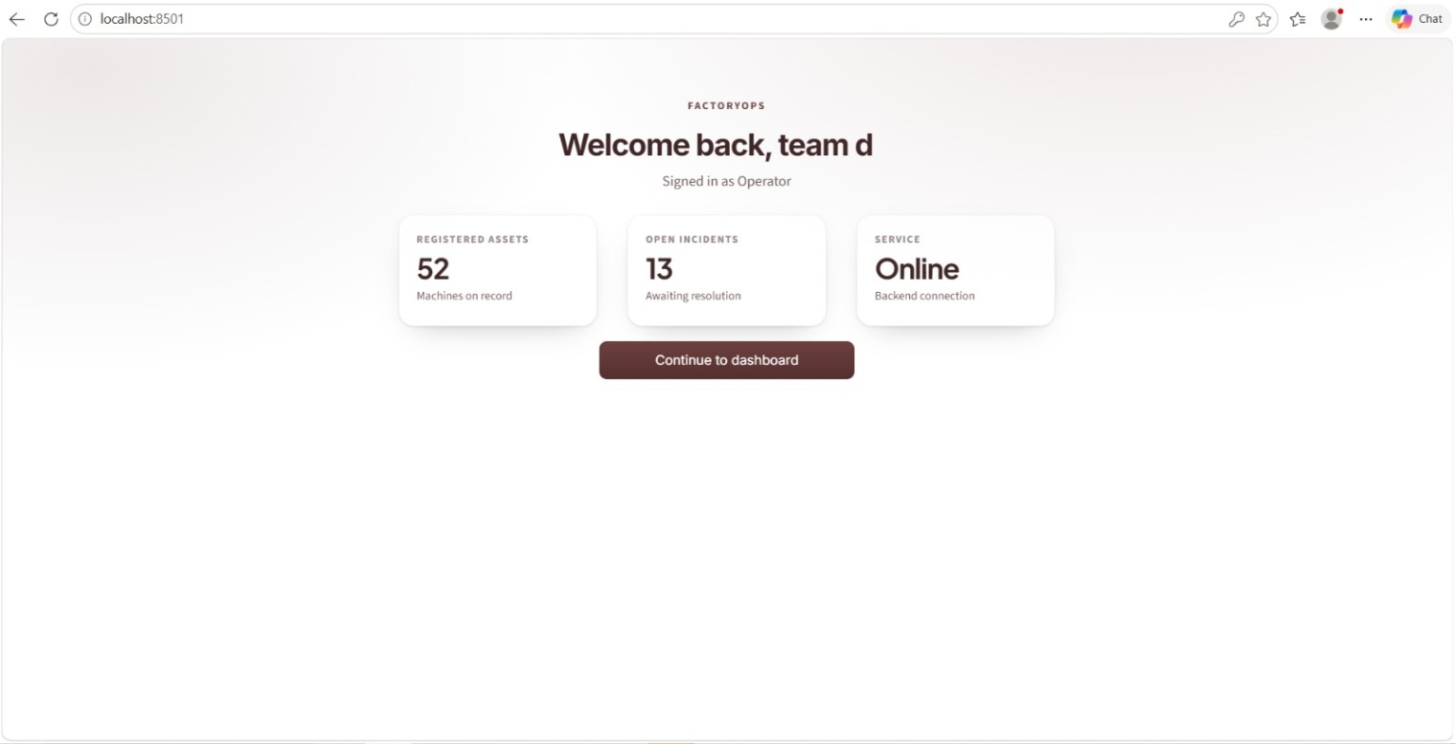
Snapshot 6.3: FactoryOps Main Operations Dashboard
Executive summary showing fleet availability (37/52), average plant health (83%), failure risk rankings, and critical attention items (Cooling System, Quality Scanner).
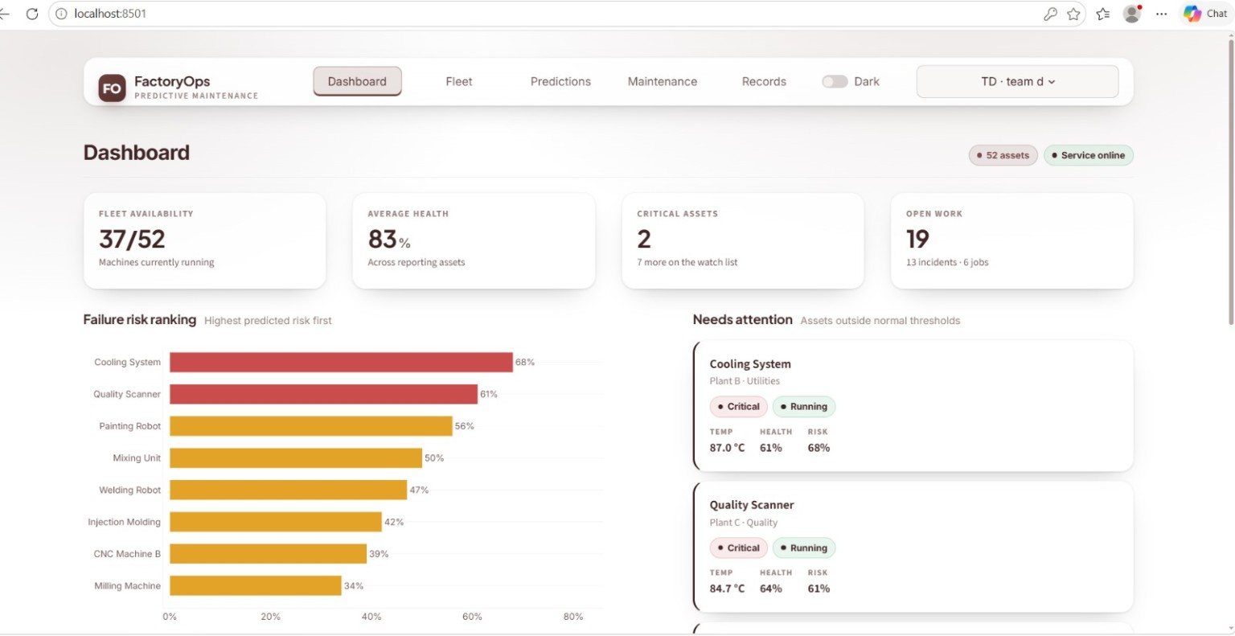
Snapshot 6.4: Fleet Asset Registry
Detailed live telemetry table tracking machine statuses, plant locations, temperatures, health indicators, and risk levels across departments.
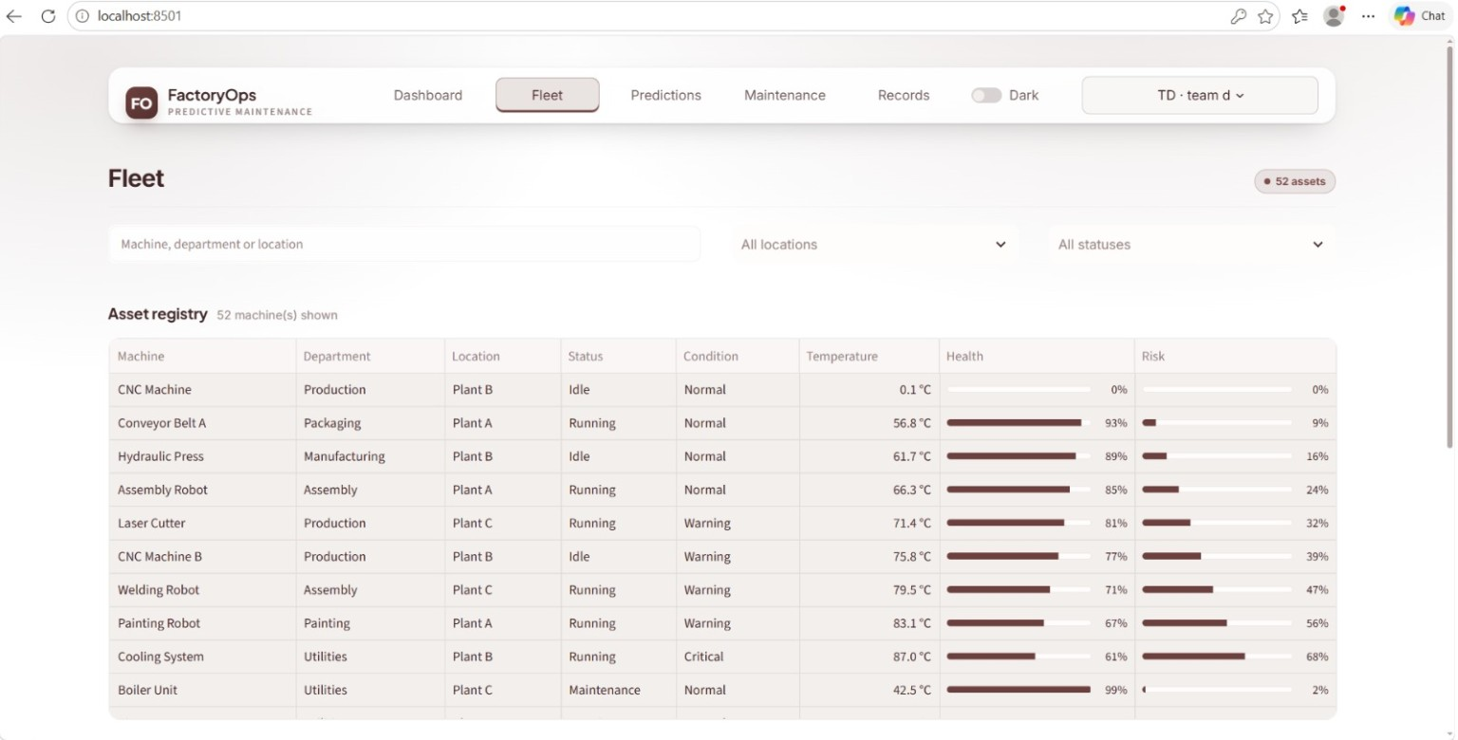
Snapshot 6.5: Predictive Failure Analytics & Priority Queue
Health vs. Risk scatter chart mapping operational probability against health scores alongside an actionable Priority Queue for high-risk equipment.
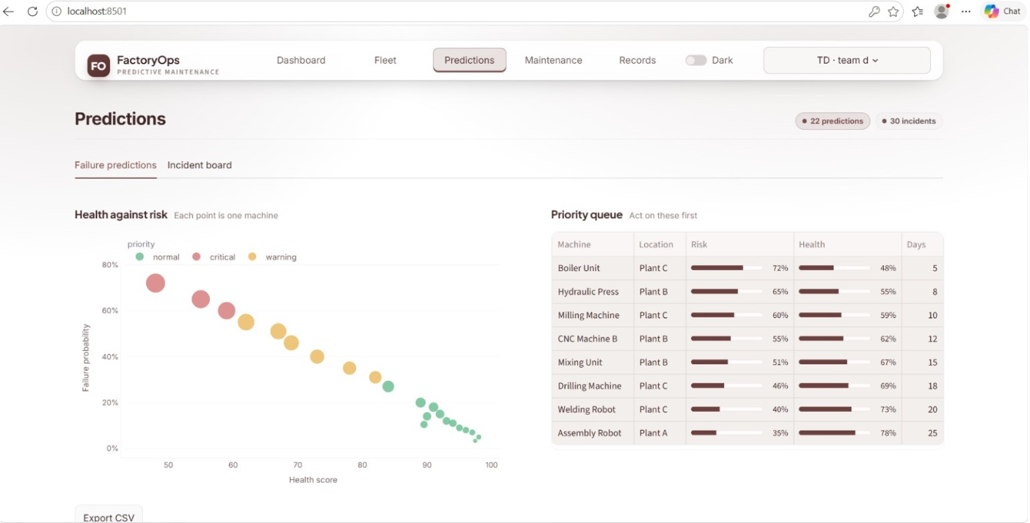
Snapshot 6.6: Maintenance & Work Order Management
Jobs by status analytics (24 completed, 4 scheduled, 2 in progress) and detailed work order records with technician cost tracking.

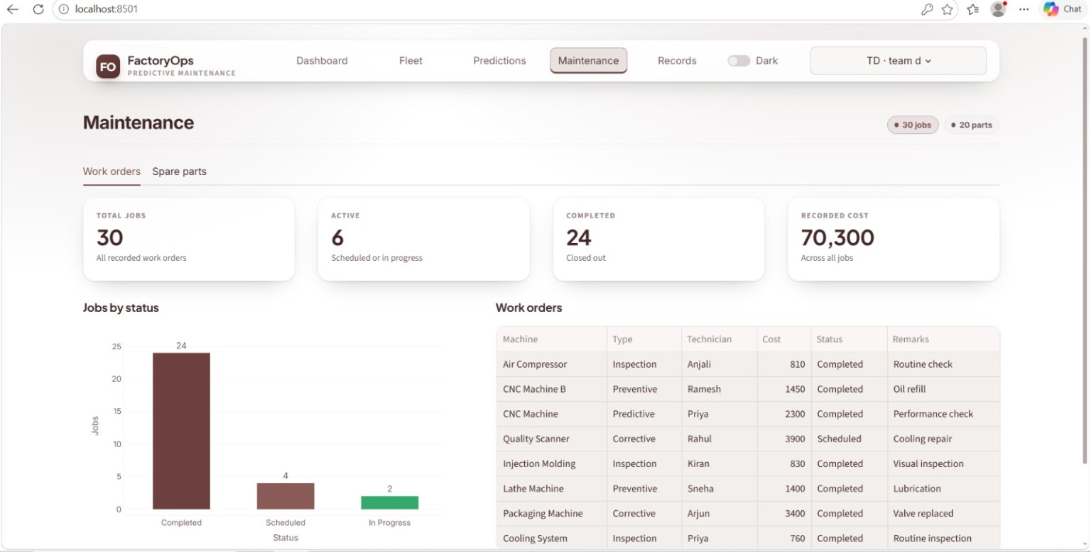

Snapshot 6.7: Records & Asset Registration Module
Form interface for registering new machines into plant departments and configuring initial parameters.
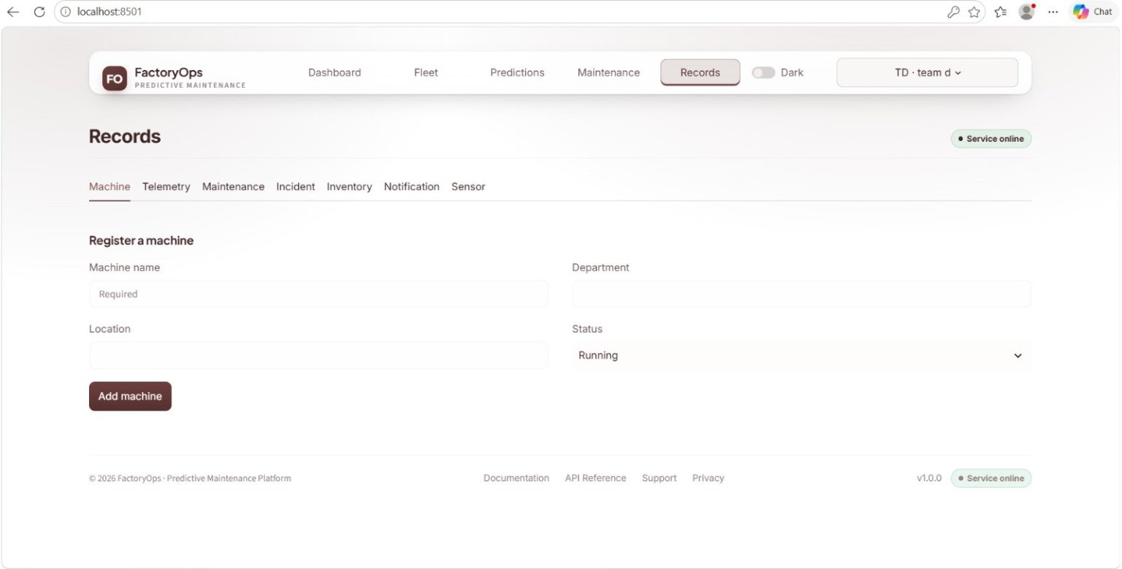

7. Challenges Faced
- Real-time Telemetry Synchronization: Managing concurrent telemetry data streams across 52 assets without UI latency. Resolution: Implemented optimized state management and cached API responses.
- Accuracy of Risk Predictions: Balancing true positive risk alerts without generating unnecessary maintenance overhead. Resolution: Fine-tuned classification model threshold parameters based on operational heat indices.
- Multi-member Remote Collaboration: Coordinating tasks across 7 team members. Resolution: Assigned clear module responsibilities (UI, ML backend, documentation) and held weekly syncs under mentor Selciya's guidance.
8. Learnings & Skills Acquired
- Technical Skills: Machine Learning for Predictive Analytics, Full-Stack Web Development, Data Visualization, RESTful API design.
- Domain Knowledge: Industrial IoT telemetry, plant asset management, preventive maintenance strategies, operational risk metrics.
- Soft Skills: Collaborative software engineering, time management, technical presentation, cross-functional teamwork.
9. Testimonials from Team
- Rajeswari & Eswar: "Building FactoryOps helped us understand how AI models directly prevent industrial equipment failures in real-time."
- Sachin & Sindhukay: "Collaborating on the frontend dashboard and translating raw data into actionable risk charts was an enriching experience."
- Vabyasha, Vaishnavi & Vyshnavi: "Working under Batch 2 with our mentor Selciya taught us how to manage full product lifecycles effectively."

10. Literature and Background Study
Industrial organizations depend on the availability and reliability of machines, production lines, utilities, and safety systems. A small failure in a critical asset can interrupt production, increase energy consumption, delay customer deliveries, and create safety risks. Traditional maintenance practices are generally classified as reactive, preventive, and predictive maintenance. Reactive maintenance is carried out after a failure, preventive maintenance follows a fixed calendar, and predictive maintenance uses condition data and analytical models to estimate when intervention is required.
FactoryOps is based on the idea that maintenance decisions should be supported by evidence rather than intuition alone. Sensor readings, machine status, maintenance history, incident records, and operational context are combined to provide a more complete view of plant health. The system therefore acts as a decision-support platform for operations leads and administrators, while final maintenance decisions remain under the control of qualified personnel.
The background study also considered the importance of visualization. Large tables of sensor readings are difficult to interpret during a busy production shift. Dashboards convert raw telemetry into indicators, trends, alerts, and queues. This allows a user to move from a plant-level summary to a specific asset and then to a work order without changing systems.

11. Existing System and Proposed System

11.1 Existing System
In a conventional plant environment, equipment information may be distributed across spreadsheets, paper inspection sheets, messaging applications, and separate maintenance software. This fragmentation creates delays in identifying repeated failures and makes it difficult to compare the condition of assets across plants. Technicians may also receive work requests without a consistent priority or sufficient diagnostic information.

11.2 Proposed FactoryOps System
The proposed FactoryOps platform creates a centralized operational view. Assets are registered with identifying information and plant context. Telemetry is received through backend services, transformed into usable indicators, and displayed through the dashboard. The prediction module assigns a risk estimate, while the maintenance module records the action taken and its status.
The system is designed to be modular. Authentication and access control protect the platform, the fleet module manages assets, the prediction module evaluates risk, and the work-order module supports execution. This separation simplifies maintenance of the application and makes it possible to improve one module without redesigning the complete platform.

12. Functional Requirements
• User authentication: The platform shall allow authorized administrators and operations leads to sign in securely.
• Role-based access: The platform shall present functions according to the responsibilities of each user role.
• Asset registration: Users shall be able to register machines with plant, department, status, and operating parameters.
• Telemetry monitoring: The platform shall display temperature, operational status, health percentage, and risk-related values.
• Prediction support: The system shall calculate or display failure probability and categorize assets according to priority.
• Incident management: Users shall be able to review open incidents and connect them to affected assets.
• Work-order tracking: Users shall be able to create, assign, update, and close maintenance jobs.
• Analytics: The dashboard shall show fleet availability, health distribution, risk ranking, and job status summaries.
• Record management: Asset and maintenance information shall remain available for later review and reporting.

13. Non-Functional Requirements
Performance: Dashboard actions should respond promptly, and frequently requested information should be handled efficiently through suitable API and state-management strategies.
Reliability: The platform should continue to provide a useful operational view even when individual telemetry values are delayed or temporarily unavailable.
Security: Authentication, role permissions, input validation, and controlled access to operational records are required to protect plant information.
Scalability: The design should allow additional plants, assets, users, and telemetry streams to be added without changing the fundamental workflow.
Usability: Labels, color indicators, charts, and status values should be understandable to operations personnel who may not have a machine-learning background.
Maintainability: Frontend, backend, database, and AI services should be organized as clear modules with documented interfaces.

14. System Architecture
FactoryOps follows a layered architecture. The presentation layer contains the dashboard, fleet view, prediction charts, maintenance screens, and registration forms. The application layer contains the business rules that validate requests, calculate derived indicators, apply role permissions, and coordinate workflows. The data layer stores asset records, telemetry values, predictions, incidents, users, and work orders. The AI layer consumes prepared data and returns a risk estimate or classification that can be used by the application layer.
A typical request begins when the user opens a dashboard or selects an asset. The frontend sends a request to the appropriate REST endpoint. The backend validates the request, retrieves the relevant records, and applies any required processing. The response is then rendered as a table, card, chart, or priority queue. For prediction-related requests, the backend supplies prepared features to the model and returns the result with the asset identifier and timestamp.
The modular architecture also supports future integration with real industrial gateways, message brokers, or cloud storage. During development, simulated telemetry can be used to test the complete flow without requiring physical machines. This makes the project suitable for demonstration, experimentation, and later extension.

15. Data Flow and Database Design
Telemetry data enters the system as readings associated with a machine and a time. Data preparation checks the value format, identifies the asset, and converts measurements into features such as recent temperature, trend, operating status, and historical event counts. The prediction result is stored or returned with an explanation-friendly label such as low, medium, or high risk.
The main conceptual entities are User, Plant, Asset, Telemetry, Prediction, Incident, Work Order, and Technician. A plant can contain many assets, an asset can produce many telemetry records, and an asset can be related to several incidents and work orders. A prediction belongs to an asset and should include a timestamp so that changes in risk can be examined over time.
Good data quality is essential. Missing readings should be flagged rather than silently treated as normal values. Duplicate records should be detected where possible, and timestamps should be consistent. These practices improve the dependability of both visualizations and machine-learning outputs.

16. Machine Learning Methodology
The predictive maintenance workflow begins with data preparation. Relevant features may include temperature, vibration, operating status, health score, asset age, recent incidents, and maintenance history. Categorical values are encoded, numeric values are checked for outliers, and records are organized by asset and time.
The prepared data is divided into training and evaluation portions. A classification model can estimate whether an asset belongs to a higher-risk condition, while a probability score communicates the confidence or relative likelihood of failure. The selected threshold should balance missed failures against unnecessary alerts. In an industrial context, the cost of a missed critical failure may be much higher than the cost of inspecting a healthy machine.
Model results should not be treated as unquestionable decisions. Operations personnel need to consider the current production schedule, safety requirements, recent repairs, and direct inspection findings. For this reason, FactoryOps presents predictions as prioritization support and connects them to a human-managed maintenance workflow.

17. User Interface and Dashboard Design
The dashboard is organized around the questions an operations lead is likely to ask: How many assets are available? Which machines require attention? What is the average health of the fleet? Which incidents are open? What maintenance work is active or overdue? Key figures are displayed at the top, followed by visual analysis and detailed records.
The fleet table supports scanning and comparison. Status labels distinguish running, idle, and maintenance states, while health and risk indicators help users identify assets that need further review. The predictive analytics screen complements the table with a health-versus-risk view, allowing clusters and unusual assets to be noticed quickly.
The work-order interface closes the loop between insight and action. A risk alert becomes useful only when a responsible person can inspect the asset, assign a technician, select a job type, record cost, and update the job status. The interface therefore links predictive information with practical maintenance execution.

18. Testing Strategy and Results
Unit testing focuses on individual functions such as input validation, health-score calculation, risk categorization, and work-order status updates. Integration testing checks the communication between the frontend, REST APIs, database operations, and prediction service. Interface testing verifies that important records and indicators appear correctly for the intended user role.
Scenario testing was used to represent common operating situations. Examples include registering a new asset, receiving a high-temperature reading, generating a high-risk prediction, creating a corrective work order, assigning a technician, and closing the job after completion. Additional tests verify that incomplete inputs are rejected and that users cannot access functions outside their permissions.
The completed project demonstrated the main workflow from asset registration and telemetry display to prediction, prioritization, and maintenance tracking. The dashboard presented the available project records, including 52 registered assets, 13 open incidents, 30 total jobs, 6 active tasks, and 24 completed tasks as represented in the existing project data.

19. Security, Privacy, and Safety Considerations
Industrial operational data may reveal production capacity, equipment condition, and maintenance weaknesses. Access should therefore be limited to authorized users, and administrative functions should be separated from routine monitoring. Input validation reduces the risk of malformed data entering the system, while secure API practices help protect information exchanged between components.
Safety is especially important when predictions influence maintenance priorities. A high or low model score must not replace safety procedures, lockout and tagout requirements, inspection standards, or the judgment of trained personnel. The platform should support safe decisions by making information easier to review, not by encouraging automatic action without verification.

20. Limitations and Future Scope
The current project uses a development-oriented data flow and simulated or prepared records. A production deployment would require validated industrial sensors, reliable connectivity, stronger monitoring, formal model governance, and integration with enterprise maintenance systems. Prediction quality would also depend on the availability of sufficient historical failure data.
Future enhancements may include streaming ingestion through an industrial messaging protocol, automated model retraining, explainable prediction factors, mobile notifications, spare-parts inventory integration, maintenance-cost forecasting, and multi-plant benchmarking. A feedback mechanism could record whether an alert was useful, allowing the team to improve thresholds and reduce alert fatigue.

21. Project Management and Team Contribution
The eight-week timeline divided the project into requirement analysis, design, implementation, integration, testing, and documentation. The team structure supported parallel work on user interface development, backend services, machine-learning functions, data handling, testing, and report preparation. Weekly coordination helped maintain alignment between modules and enabled issues to be discussed under the mentor’s guidance.
A clear ownership model is useful for a project of this kind because the dashboard, APIs, prediction service, and data model must work together. Integration checkpoints ensured that a feature was not considered complete merely because it worked in isolation; it also needed to exchange data correctly with the other modules.

22. Final Outcome
FactoryOps provides a consolidated demonstration of how full-stack development and machine learning can be combined for industrial maintenance and process optimization. The platform connects operational monitoring with predictive risk analysis and work-order execution. The existing screenshots and project records document the implemented interfaces, while the expanded topics explain the design decisions, requirements, architecture, testing approach, and future possibilities.
The project also gave the team practical experience in converting a broad industrial problem into manageable software modules. It strengthened skills in requirements analysis, API development, dashboard design, data preparation, predictive analytics, testing, collaboration, and technical communication.
25 Conclusion:The FactoryOps AI-Based Industrial Maintenance & Process Optimization project successfully demonstrates how predictive analytics can transform modern factory operations. By combining live telemetry monitoring, failure risk prediction, and streamlined work order management into a unified interface, the project achieves significant efficiency gains and downtime reduction.26.Acknowledgements We extend our heartfelt gratitude to Infosys Springboard Virtual Internship 7.0 for providing this learning opportunity. Special thanks to our mentor Selciya for constant guidance, technical oversight, and support throughout the 8-week internship journey.

